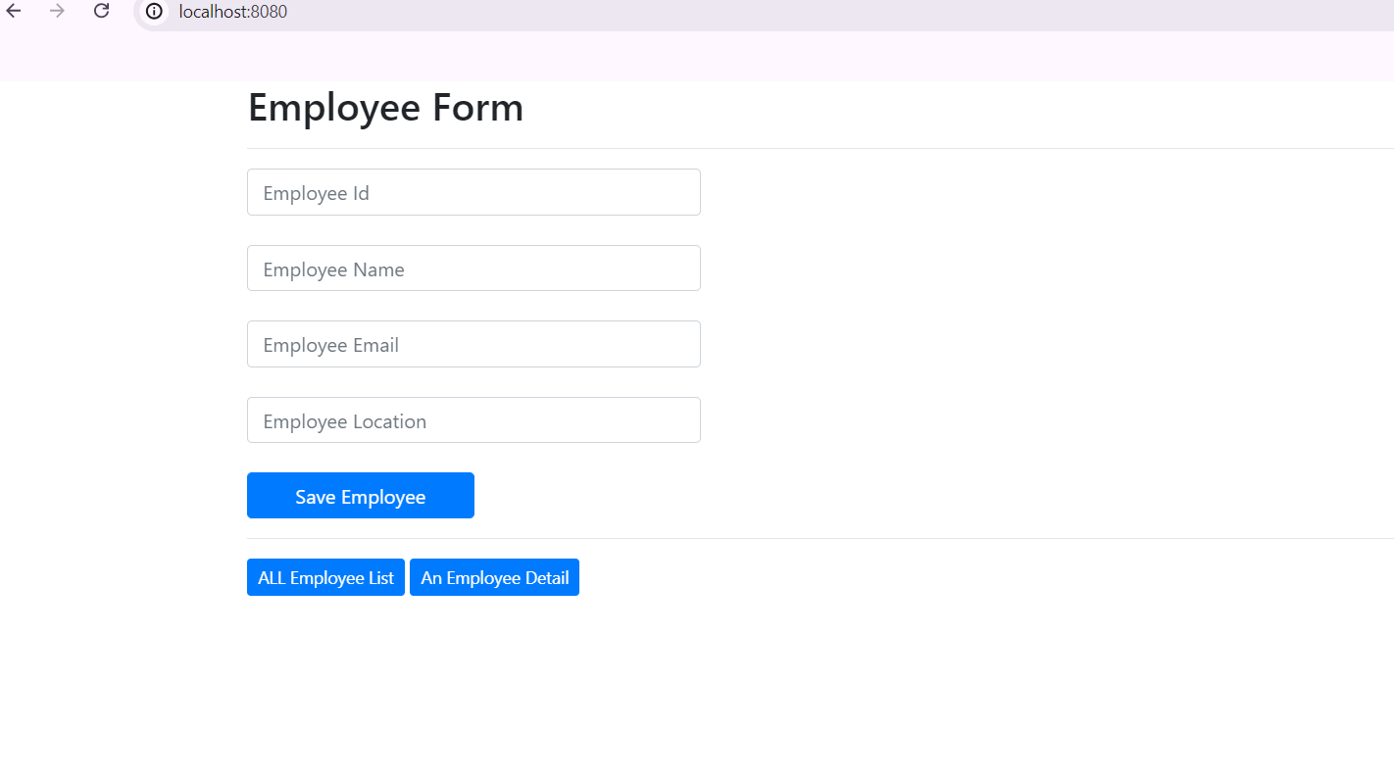

This is index page where employee details are inserted into mongoDb database use Save Employee Button

ALL Employee List button move the link to the displayAll page link.

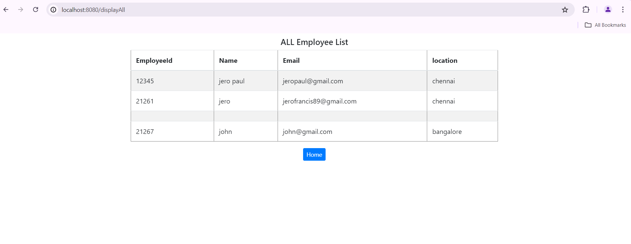

This page shows all inserted Employee List

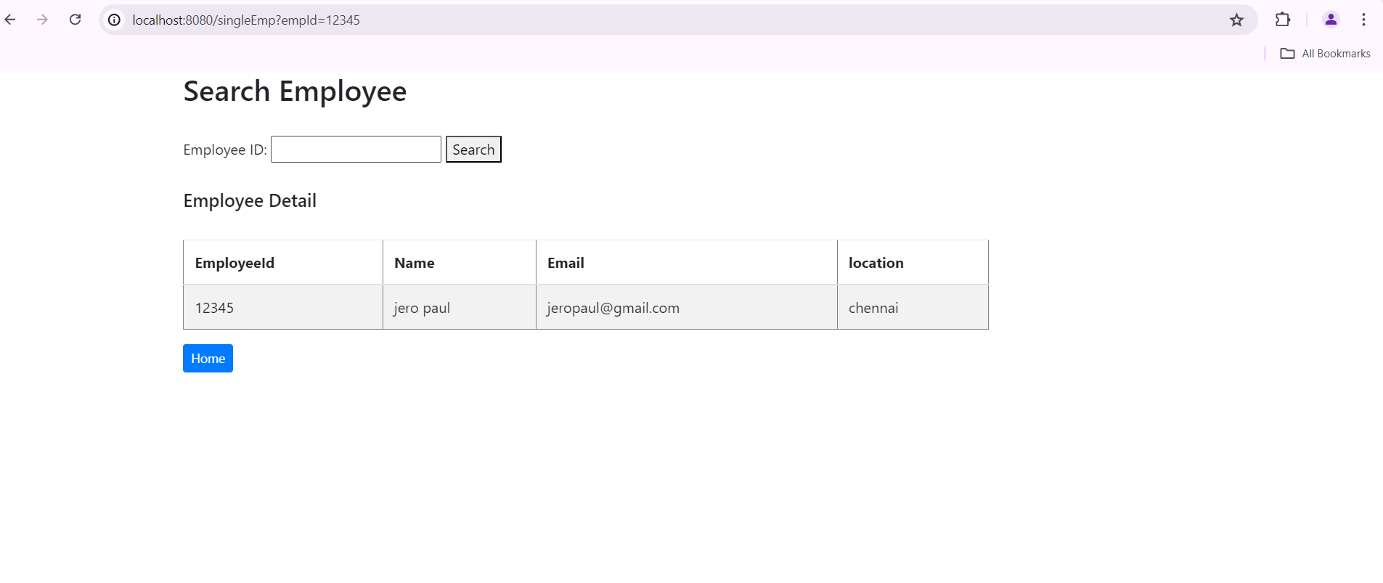

This Page shows particular Employee Details based on employeeId.

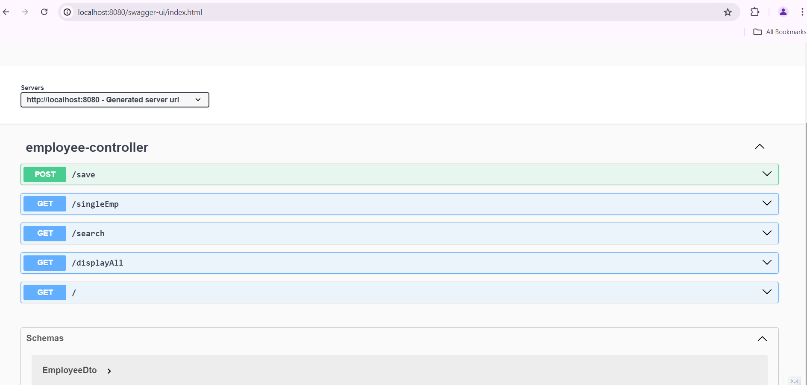

Swagger link only works with @RestController Annotation,since we cannot use @RestController annotation along with thymeleaf.i changed the annotion from @RestController annotation to @Controller.This screenshot is taken after changing the annotation from @conroller to @RestController.